**Compressed response with gzip:**

* If a client requests any response form the server, we can make it zipped and send the data to client which will reduce the time of loading.
* Now a days, all browsers are supporting decompress. So, it will be decompressed automatically by the browser.

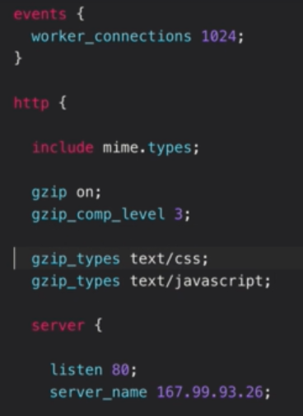

* We can just modify the config file as above, with above, we can give how many files to be zipped and also we can add the mime types of files which need to be compressed.

**fastCGI cache:**



* Let’s say a client requested a data and nginx gets it from php and show it on browser. Then we can make this cache so that the same request again need not to go to php again.